2 a)

Compare each number with the next number, but do not compare any number more than once such that you would have made n/2 comparisons. Note which number is the lowest of each comparison (and thus a candidate for min) and which is the highest (and thus a candidate for max) Repeat the process comparing each smaller value with another value that was smaller and bigger values with other bigger values, eliminating candidates for smallest and biggest until you have arrived at a single value. Example below

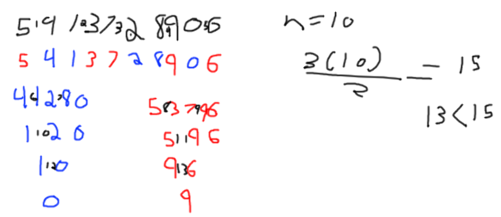

b)

Considering just one row, deploy binary search to check the middle value, then checking the middle right value if the middle value is a one or checking the left middle value if the middle is a one. By using this cut-in-half search we can look for a “1,0” pattern that will tell us exactly how many 1s are in the row. Binary search gives us logn actions per row, and we have n rows, so nlogn actions